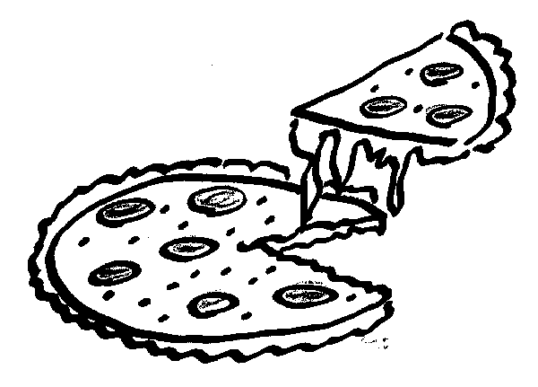
Saint Mary’s School December Food Order Form
COMPLETE A SEPARATE FORM FOR EACH CHILD

If you wish to order food /milk, please complete the form below and submit payment by
Mon. Nov. 19/18 for food and milk for the month of December. No further orders can be accepted after this date as time is required to tabulate orders and provide this information to our suppliers and to classroom teachers. Please keep in the mind the following:

Thank you.

Ms. L. Hetherington
Office Administrator

Student Name:___ ____________________________________________ Teacher:________________________________
First and Last Name

Item | Quantity | Item | Quantity
Pizza Dec.05/18 | ____ x$2.00 = _____ | Hot Dogs Dec.07/18 | ____ x$1.50 = _____
Pizza Dec.12/18 | ____ x$2.00 = _____ | Hot Dogs Dec.14/18 | ____ x$1.50 = _____
Pizza Dec.19/18 | ____ x$2.00 = _____ | Hot Dogs Dec.21/18 | ____ x$1.50 = _____
Pizza Total | $ | Hot Dog Total | $

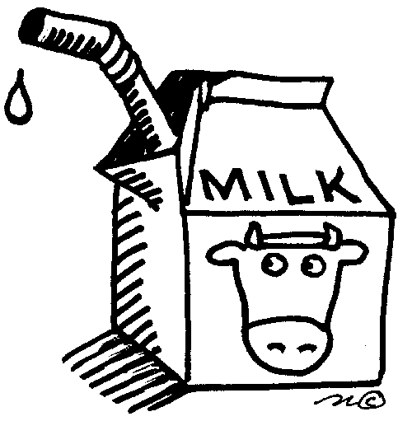
- I wish my child to have milk everyday (15 days X $ .80 each) = 12.00
  - Chocolate
  - White
or….
- I wish my child to have milk only on the following days only in December:
Monday | Tuesday | Wednesday | Thursday | Friday
3 ___ Choc ___White | 4___ Choc ___White | 5___ Choc ___White | 6___ Choc ___White | 7___ Choc ___ White
10 ___ Choc ___ White | 11 ___ Choc ___ White | 12 ___ Choc ___ White | 13___ Choc ___ White | 14___ Choc ___ White
17 ___ Choc ___ White | 18 ___ Choc ___ White | 19 ___ Choc ___ White | 20 ___Choc ___ White | 21___ Choc ___ White

Grand Total of order: ______________________

Cheques are much preferable to, and safer than cash. Please make cheque payable to “Saint Mary’s School”. If you are using refund tickets for partial payment, you must attach them to this form with payment.

Office Use: ______cash ________cheque #________
Tickets ___________

