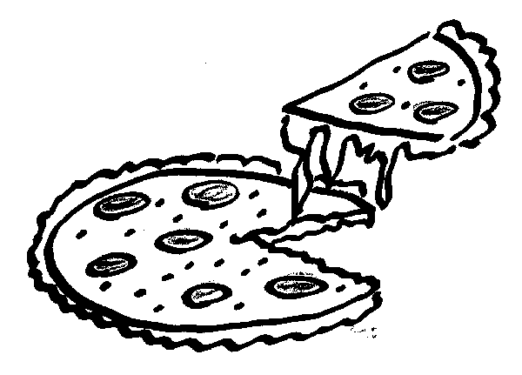
Saint Mary’s School April Food Order Form
COMPLETE A SEPARATE FORM FOR EACH CHILD

If you wish to order food /milk, please complete the form below and submit payment by
Mon. Mar.18/19 for food and milk for the month of April. No further orders can be accepted after this date as time is required to tabulate orders and provide this information to our suppliers and to classroom teachers. Please keep in the mind the following:

Thank you.

Ms. L. Hetherington
Office Administrator

Student Name:___ ____________________________________________ Teacher:________________________________
First and Last Name

Item | Quantity | Item | Quantity
Pizza Apr. 03/19 | ____ x$2.00 = _____
Pizza Apr. 10/19 | ____ x$2.00 = _____
Pizza Apr. 17/19 | ____ x$2.00 = _____
Pizza Apr. 24/19 | ____ x$2.00 = _____
Pizza Total | $

****** Lent begins on March 6-April 18/19 so cheese pizzas only will be eaten during this time. ******

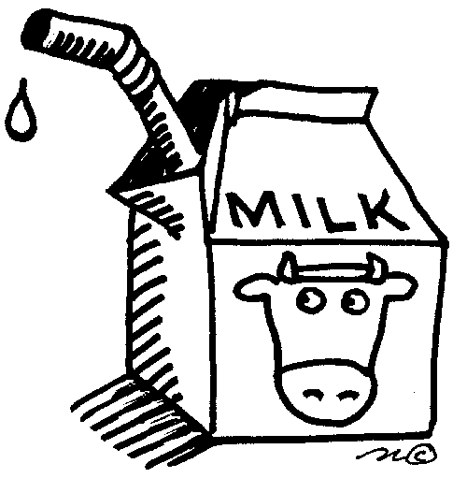
- I wish my child to have milk everyday (20 days X $ .80 each) = 16.00
  - Chocolate
  - White
or….
- I wish my child to have milk only on the following days only in April:
Monday | Tuesday | Wednesday | Thursday | Friday
1 ___ Choc ___ White | 2 ___ Choc ___ White | 3 ___ Choc ___White | 4 ___ Choc ___White | 5___ Choc ___ White
8 ___ Choc ___ White | 9 ___ Choc ___ White | 10 ___ Choc ___ White | 11 ___Choc ___ White | 12 ___Choc ___ White
15 ___ Choc ___ White | 16 ___ Choc ___ White | 17 ___ Choc ___White | 18 ___ Choc ___White | 19 Good Friday
22 Easter Monday | 23 ___ Choc ___ White | 24 ___ Choc ___White | 25 ___ Choc ___White | 26 ___ Choc ___White
29 ___ Choc ___ White | 30 ___ Choc ___ White

Grand Total of order: ______________________

Cheques are much preferable to, and safer than cash. Please make cheque payable to “Saint Mary’s School”. If you are using refund tickets for partial payment, you must attach them to this form with payment.

Office Use: ______cash ________cheque #________
Tickets ___________

